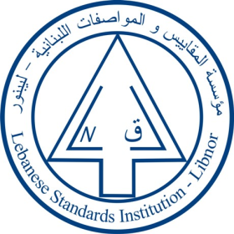
The Lebanese Standards Institution
Invites you to attend the

“Good Manufacturing practices”
(مقدمة عن السلامة الغذائية و حسن ممارسة التصنيع)
Training course
Under the Food safety training program
Offered by LIBNOR training center
Date: 10-11 October 2017 Time: 9:00 A.M. Till 15:00 P.M.
Companies are invited to contact us to register nominated candidate on
training@libnor.org

